**Full Tree Traversal**

Traversal is a process to visit all the nodes of a tree and also can print all the value.There are three kind of tracersal:-

* In-order Traversal
* Pre-order Traversal
* Post-order Traversal

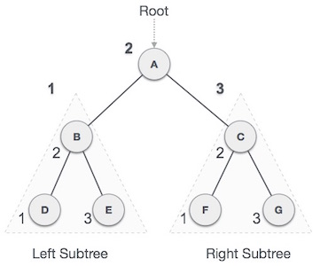

In-order Traversal: D → B → E → A → F → C → G

## Pre-order Traversal:A → B → D → E → C → F → G

## Post-order Traversal:D → E → B → F → G → C → A

## Cycle Finding

## 

## 

## First one is cycle but second one is not cycle because 2 and 4 is not connected with each other.

## Component Finding

## 

## 4,40,5,6 are connected with each other but they are not connected with 2,10,1,20,3,30 but 2,10,1,20,30 are connected with each other so we can say that there is two component

## 2,10,1,20,3,30

## 4,40,5,6

## Articulation Point Finding

A vertex in an undirected connected graph is an articulation point (or cut vertex) iff removing it (and edges through it) disconnects the graph. Articulation points represent vulnerabilities in a connected network – single points whose failure would split the network into 2 or more components. They are useful for designing reliable networks.  
For a disconnected undirected graph, an articulation point is a vertex removing which increases number of connected components.

Following are some example graphs with articulation points encircled with red color.  
[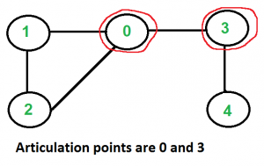](https://media.geeksforgeeks.org/wp-content/cdn-uploads/ArticulationPoints.png)  
[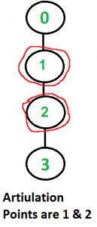](https://media.geeksforgeeks.org/wp-content/cdn-uploads/ArticulationPoints1.png)  
[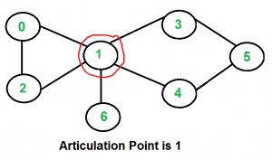](https://media.geeksforgeeks.org/wp-content/cdn-uploads/ArticulationPoints21.png)

**Topological Sort**

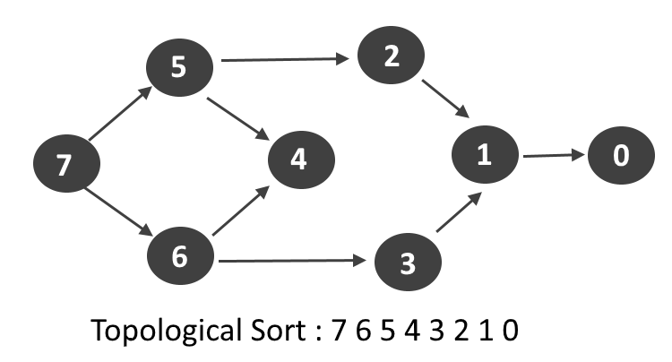

Topological Sort: 7,6,5,4,3,2,1,0

## Strongly Connected Components

In the mathematical theory of directed graphs, a graph is said to be strongly connected if every vertex is reachable from every other vertex. The strongly connected component of an arbitrary directed graph form a partition into subgraphs that are themselves strongly connected.

A directed graph is strongly connected if there is a path between all pairs of vertices. A strongly connected component (ssc) of a directed graph is a maximal strongly connected subgraph. For example, there are 3 SCCs in the following graph.

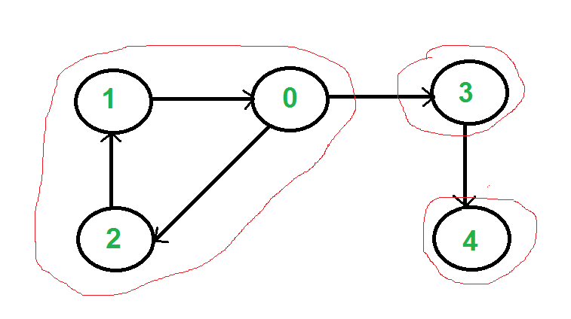

We can find all strongly connected components in O(V+E) time using Kosaraju’s algorithm. Following is detailed Kosaraju’s algorithm.

1. Create an empty stack ‘S’ and do DFS traversal of a graph. In DFS traversal, after calling recursive DFS for adjacent vertices of a vertex, push the vertex to stack. In the above graph, if we start DFS from vertex 0, we get vertices in stack as 1, 2, 4, 3, 0.
2. Reverse directions of all arcs to obtain the transpose graph.